**Project Name:** Covid Awareness Website

**Github Link:** https://github.com/projectsforstudents2022/Covid_Awareness_Website.git

**Why was this project created?**

The COVID-19 epidemic, which started locally in Wuhan, China, has spread to practically every country in the world. Threats to human civilizations' existence and well-being are present. No country is receiving any significant relief or solutions from this pandemic; instead, they are trying to educate and persuade their inhabitants to take precautions by altering their lifestyles.

**What problem is it solving?**

The goal was to lessen the spread of viruses in society, spread important information, provide quality healthcare, and prevent social and economic loss. WHO also concentrated on developing a quick and efficient diagnosis system to stop infection.

**Entire explanation of project**

* **PROPOSED APPROACH**

As a response to the COVID-19 pandemic, this project intends to create content for the Physiopedia COVID 19 category as well as the Respiratory and Mental Health Sections. We want to provide the website with useful, reliable, and thought-provoking data on every facet of treating patients with a COVID-19 diagnosis. There is still much to learn from the initial cases of the coronavirus one year ago. The incapacitating effects of COVID during the "recovery" period, notwithstanding the severity of the acute stage, is one of the recent discoveries. The pages developed/reviewed are updated frequently when new information becomes available as part of the continuing learning connected with COVID.

* **RESULT**

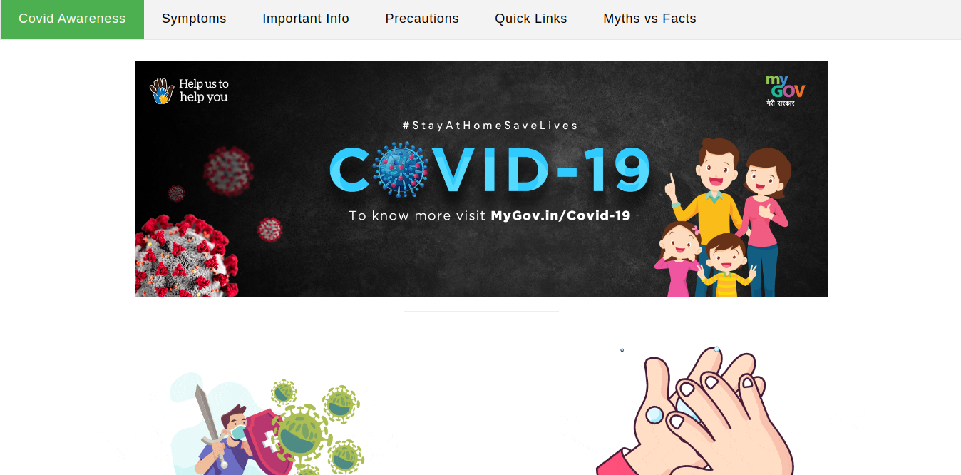

**CONCLUSION**

Urban residents who were primarily literate were aware of the coronavirus pandemic at the time. They are aware of virus infection symptoms including fever, coughing, sore throat, fatigue, and running noses, as well as possible transmission methods, thus the government and famous individuals should uplift the spirits of the common people during this trying time. People expressed trust in the ability to avoid sickness but expressed worry about the potential damage from pandemics.